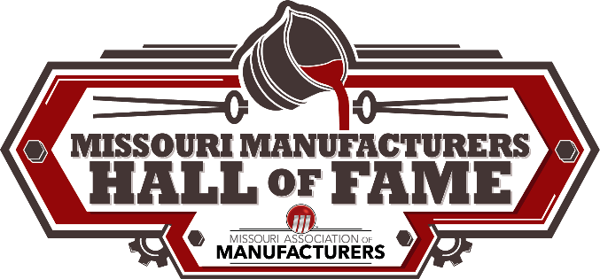

Missouri Manufacturers Hall of Fame - Nomination Form
Induction Ceremony to be held in early 2025.

Categories:
- Individual- Owner, Leader, Manager, Other
- Company/Corporation/Organization

Criteria:
Individual nominees for Missouri Manufacturers Hall of Fame induction must be an individual who participated in manufacturing or completed at least fifteen years of service in manufacturing within the state of Missouri. A nominee must have made substantial contributions to the manufacturing industry to be considered. Personal accomplishments, leadership, community service, and career achievements will also be considered.
Company/Corporation/Organization nominees for Missouri Manufacturers Hall of Fame induction must be a Missouri Manufacturer operating for at least fifteen years. A nominee must have made substantial contributions to the manufacturing industry to be considered. Organizational accomplishments, leadership, community service, and achievements will also be considered.
Deadline:
All nominations must be received by Friday, August 30, 2024. Please submit to Jeff Cumley, Associate Director, Missouri Association of Manufacturers, 1329 E. Republic Rd., Ste. J, 65804, or email jcumley@mamstrong.org.
Selection:
The Hall of Fame committee will select candidates from those that are nominated to be inducted into the Hall of Fame. Each candidate selected must be able to attend the induction ceremony held in late February. Each inductee will be notified of his/her selection in early January.
*In order to type into the fields on this form and submit via email, download to your computer, type into each section and save your progress. The completed form can then be attached to an email.
Nominee:
Name: ______________________________________ Phone Number: ___________________

Company Name: ____________________________________ Retired? ___Yes ___No
Current Address: _________________________________
_________________________________
E-Mail Address: ______________________________________

Total years involved in Manufacturing: ___________

Manufacturing Accomplishments/Achievements/Awards: ______________________________________ _________________________________________________________________________________________________________________________________________________________________________________________________________________________________________________________ Continue on additional page, if needed.
Why do you think this candidate should be nominated into the Missouri Manufacturers Hall of Fame?
__________________________________________________________________________________________________________________________________________________________________________________________________________________________________________________________________________________________________________________________________________________________________________________________________________________________________________________________________________________________________________________
Continue on additional page, if needed.

Nominator: ________________________________________
Name: _______________________________________ Phone Number: __________________

Current Address: ______________________________________
______________________________________
______________________________________
E-Mail Address: __________________________________________________

*Any additional information may be attached to the nomination form.

