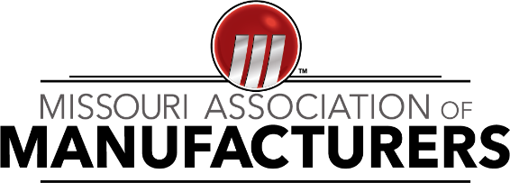
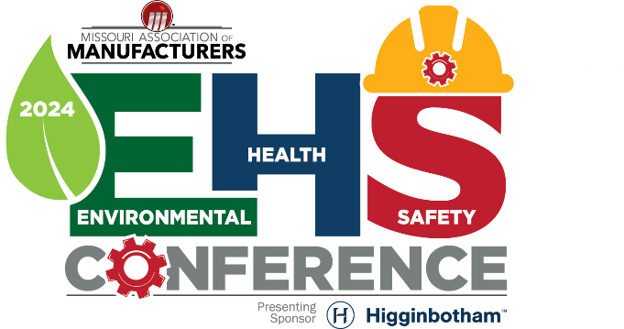

2024 Safety Award Application

Thank you for your interest in applying for the Missouri Association of Manufacturers 2024 Safety Awards. By submitting this application, you certify that the information contained in this document is correct to the best of your knowledge. Falsifying information will result in an ineligible application.
If chosen as a top applicant, you must agree to an on-site assessment of your safety program (conducted by SMC, in partnership with MAM) to remain eligible to win the Leader of the Pack and/or Safety Innovation of the Year Award. Dates of these assessments will run between July 15 – August 16, 2024. Inability to complete an on-site assessment will disqualify the applicant from receiving any award.
Please send this completed application, along with any other requested files, to info@mamstrong.org. The deadline for this application is June 30, 2024.

COMPANY INFORMATION
Company Name: Click or tap here to enter text.
Company Address (Street, City, State & ZIP): Click or tap here to enter text.
Single or Multi-site? ☐ single ☐ multi Number of Employees: Click or tap here to enter text.
Description of work done at facility: Click or tap here to enter text.

EMPLOYEE REPRESENTATIVE INFORMATION
First Name: Click or tap here to enter text. Last Name: Click or tap here to enter text.
Email: Click or tap here to enter text. Phone Number: Click or tap here to enter text.

PROCEDURES & POLICIES
- Does the company have all applicable OSHA required programs implemented? These include (if deemed applicable to facility’s operation): Lockout Tagout, Hearing Conservation, Hazardous Communication, Confined Space, Respiratory Protection, Electrical Safety, Hot Work, Crane/Hoisting Inspection, etc. ☐ YES ☐ NO
- Which one of these OSHA programs does your company implement best, and why?
  - Click or tap here to enter text.
- Are all employees trained on all applicable safety policies and procedures? ☐ YES ☐ NO
- Does the company have all applicable OSHA required WRITTEN programs documented and in place? These include (if deemed applicable to facility’s operation): Emergency Action Plan, Fire Prevention Plan, Hazard Communication, Confined Space, Respiratory Protection, Recordkeeping, etc. ☐ YES ☐ NO

INCIDENT MANAGEMENT
- Please explain how incidents are reported.
  - Click or tap here to enter text.
- Are near misses reported? ☐ YES ☐ NO
- Are good catches reported? ☐ YES ☐ NO
- Please provide a blank copy of the company’s Incident Form.
- What percentage of incidents/near misses are investigated to determine root cause?
Choose an item.
- What percentage of incidents are effectively controlled or given corrective actions within 30 days after the incident? Choose an item.
- How are these corrective actions communicated to the applicable workers?
  - Click or tap here to enter text.
- What percentage of recordable/reportable incidents or injuries are properly communicated to OSHA? Choose an item.

HAZARD ASSESSMENT & PREVENTION
- Does the company frequently assess workplace hazards? ☐ YES ☐ NO
- Please give 3 (or more) examples of how hazards are identified/assessed.
  - Click or tap here to enter text.
  - Click or tap here to enter text.
  - Click or tap here to enter text.
  - Click or tap here to enter text. (Optional)
- Please explain how these identified hazards are communicated to workers.
  - Click or tap here to enter text.
- What percentage of these identified hazards are effectively mitigated to the lowest reasonable level? Choose an item.
- Is there a Lockout Tagout (LOTO) program with equipment procedures implemented at the facility? ☐ YES ☐ NO
- Please provide an example of a LOTO procedure in use at the facility.
(ATTACH FILE OF PROCEDURE WHEN SUBMITTING APPLICATION)
- Please describe how the safety team determines effective controls/corrective actions for identified hazards?
Click or tap here to enter text.

TRAINING PROGRAM
- Is there an effective safety training program implemented at the facility? ☐ YES ☐ NO
- What percentage of workers are included in the safety training program? Choose an item.
- Does the program include all OSHA required topics such as the Emergency Action Plan and Fire Prevention Plan (amongst others)? ☐ YES ☐ NO
- What are some safety trainings that are conducted for workers? Please list as many as possible.
  - Click or tap here to enter text.
- Does the company keep all required training certificates and documents? ☐ YES ☐ NO
Paper or digital? ☐ Paper ☐ Digital

SAFETY CULTURE
- Does the company have internal groups/teams/staff solely focused on safety? Please list as many of these as you can think of.
  - Click or tap here to enter text.
- What are the 5 words you would use to describe your company’s safety culture?
  - Click or tap here to enter text.
- Does the company strive to continuously improve the workplace safety culture? ☐ YES ☐ NO
- Does the company have safety incentive programs? Please explain.
  - Click or tap here to enter text.
- Please give 3 examples in the last year of how the company improved the workplace safety culture.
  - Click or tap here to enter text.
  - Click or tap here to enter text.
  - Click or tap here to enter text.

STANDARD COMPLIANCE
- Does the company strive to adhere to any and all applicable OSHA standards? ☐ YES ☐ NO
- To your best knowledge, what percentage of OSHA standard 1910 (General Industry) is the facility compliant with? Choose an item.
- What other safety standards (consensus standards) are used with regards to safety planning, safety management, or safety compliance? (ex – NFPA, ANSI, ASSP, etc)
  - Click or tap here to enter text.
- Please give an example or examples of how the company uses the listed standards in the question above (#32).
  - Click or tap here to enter text.
  - Click or tap here to enter text.
  - Click or tap here to enter text.

- How many OSHA citations did the company receive in 2023-2024?
  - Click or tap here to enter text.

(This completes the general application for the Missouri Association of Manufacturers 2024 Safety Awards. If you would like to apply for the Safety Innovation of the Year Award, please continue to the following page to fill out the remaining question and attach any necessary files.)

Safety Innovation of the Year Award Application
- Did the innovation address a safety issue in the workplace? ☐ YES ☐ NO
- Please describe the safety issue.
  - Click or tap here to enter text.
- Please describe the innovation and how it addresses the above-mentioned safety issue.
  - Click or tap here to enter text.
- Did you use the hierarchy of controls to resolve the safety issue? ☐ YES ☐ NO
- Which level of the hierarchy of controls was used to address the safety issue? Please explain:
Click or tap here to enter text.
- Please provide a photo of the innovation.
(ATTACH PHOTO OF INNOVATION WHEN SUBMITTING APPLICATION)
SMC’s mission is to partner with our customers to deliver strategic, end-to-end solutions aiding in the success of your business. Leveraging our years of knowledge and expertise, we work collaboratively with you to optimize operations, increase efficiency, and improve your bottom line.
To learn more, visit www.smcelectric.com.
Assessment provided by:

